Test De Personnalité et Relation "Psychique"
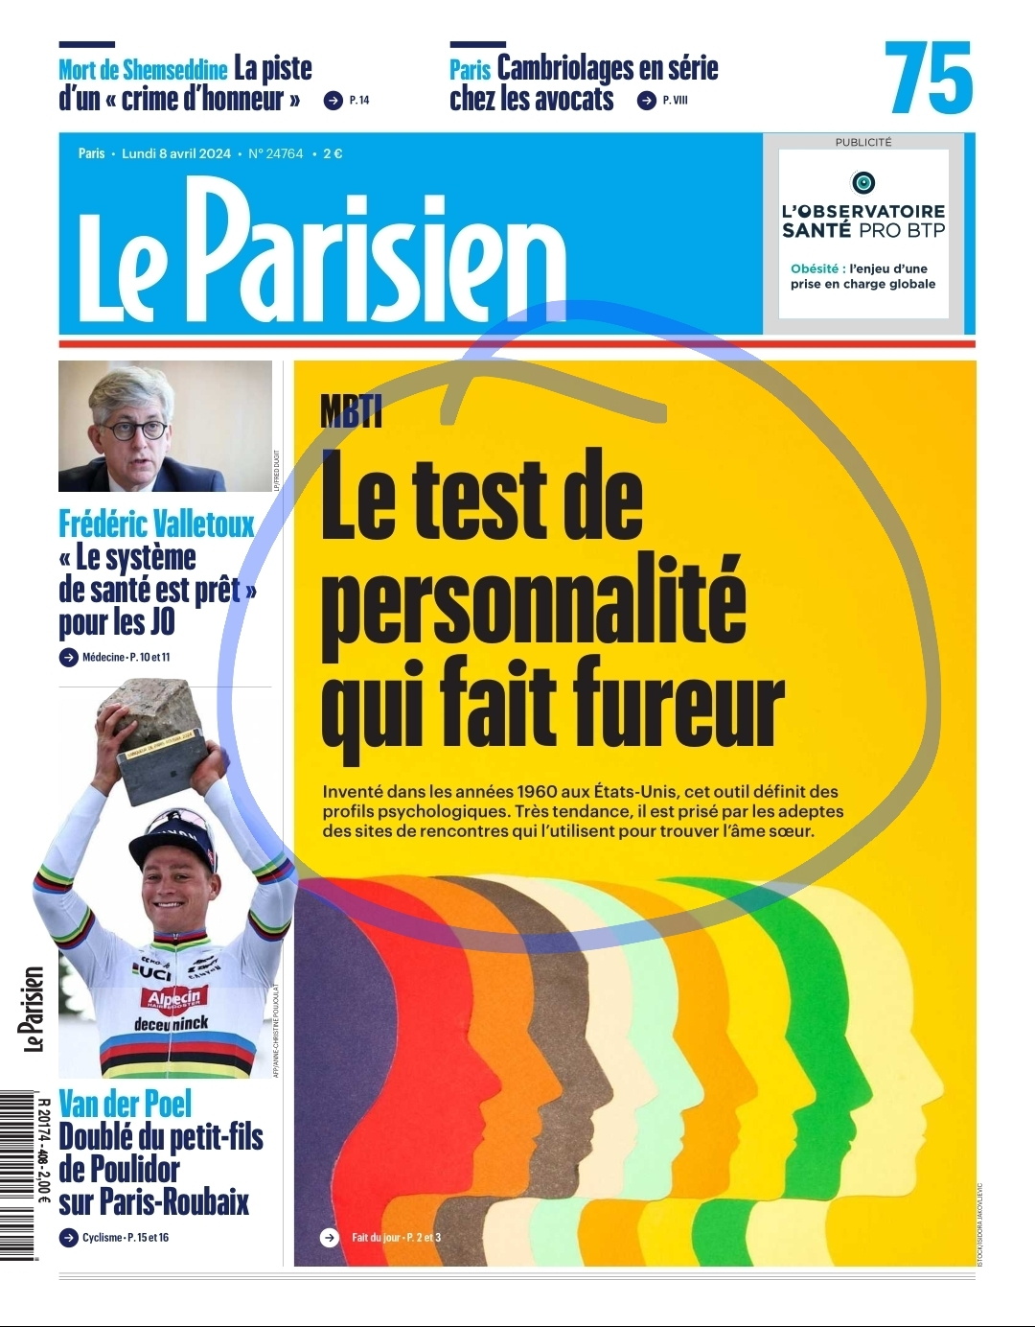
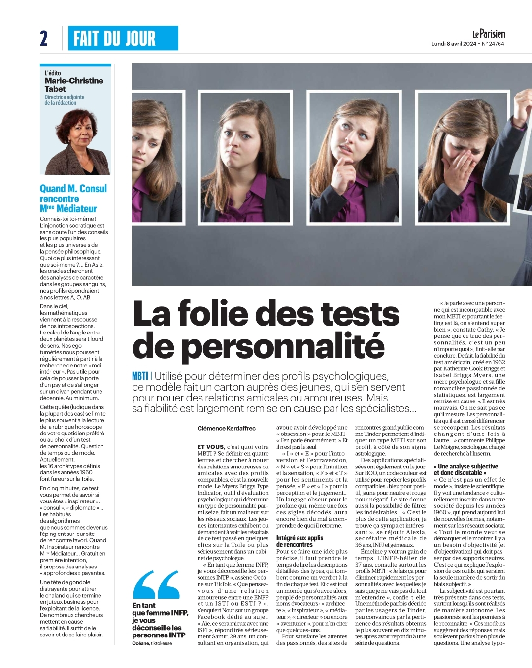
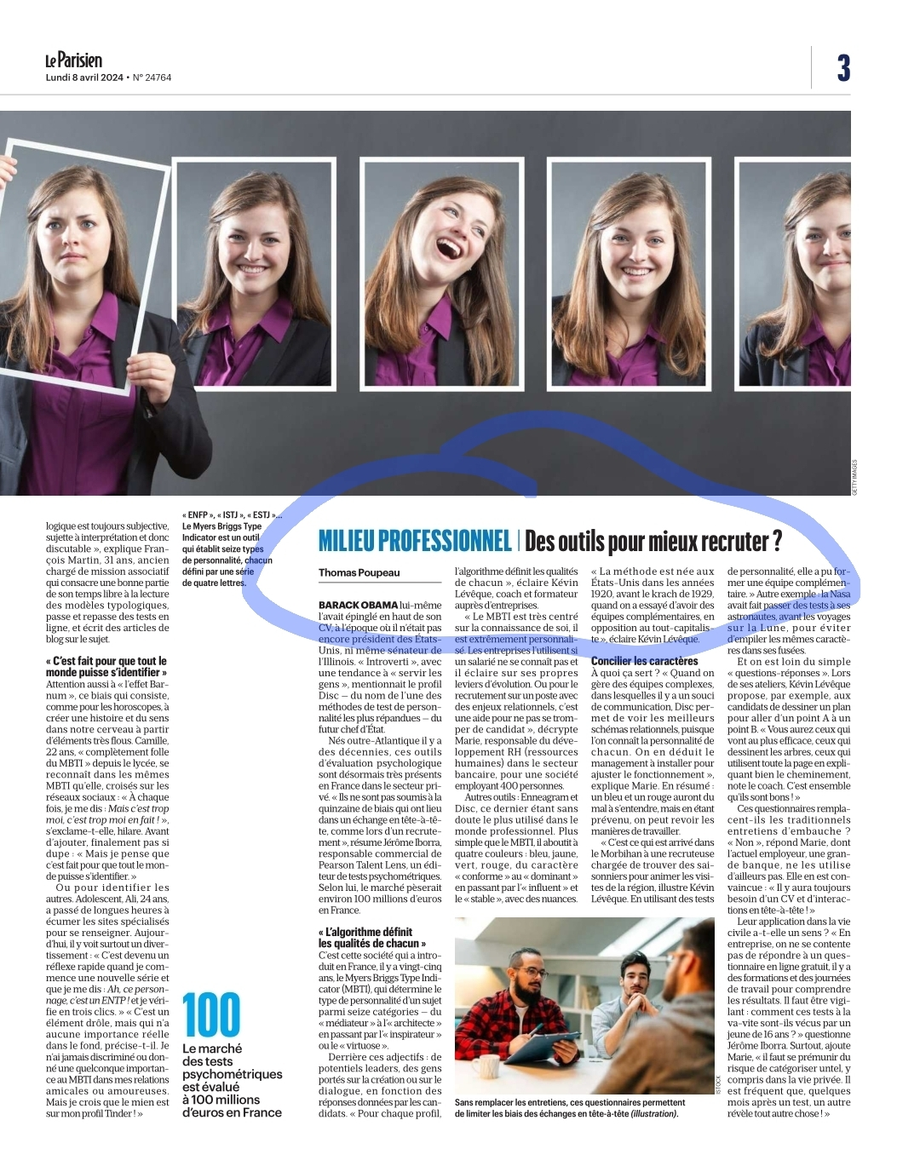
<iframe width="560" height="315" src="https://www.youtube.com/embed/WT1BRoNOT_I?si=EPF_o_YOead9_7Ow#t=4.0" title="YouTube video player" frameborder="0" allow="accelerometer; autoplay; clipboard-write; encrypted-media; gyroscope; picture-in-picture; web-share" referrerpolicy="strict-origin-when-cross-origin" allowfullscreen></iframe>
~~LINKBACK~~

