Saturation de l'effet de serre
<iframe width="250" src="https://www.youtube.com/embed/ewc8FBtEKPs?rel=0&cc_load_policy=0" title="YouTube : ewc8FBtEKPs" frameborder="0" allow="accelerometer; autoplay; clipboard-write; encrypted-media; gyroscope; picture-in-picture; web-share" referrerpolicy="strict-origin-when-cross-origin" allowfullscreen></iframe>
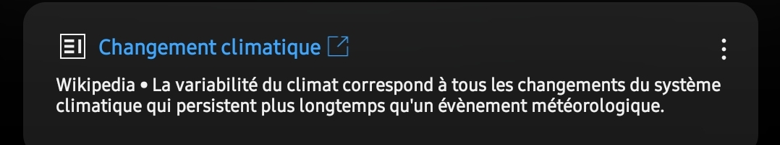
https://fr.m.wikipedia.org/w/index.php?title=Changement_climatique&diffonly=true

Comments


