Hunter & Joe Biden
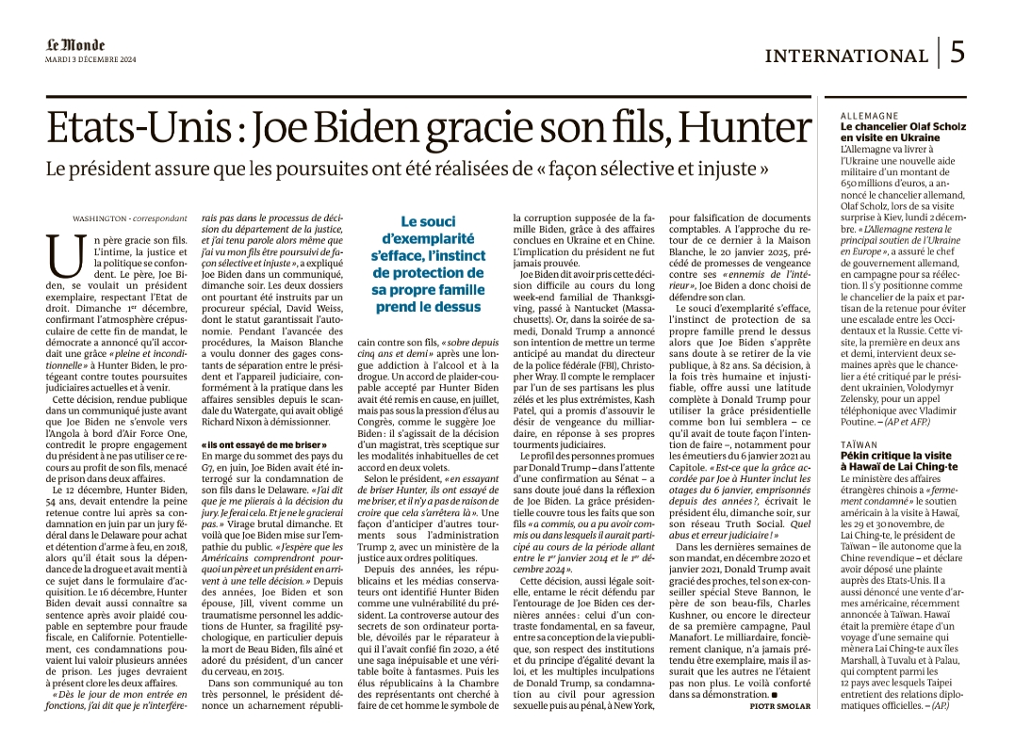
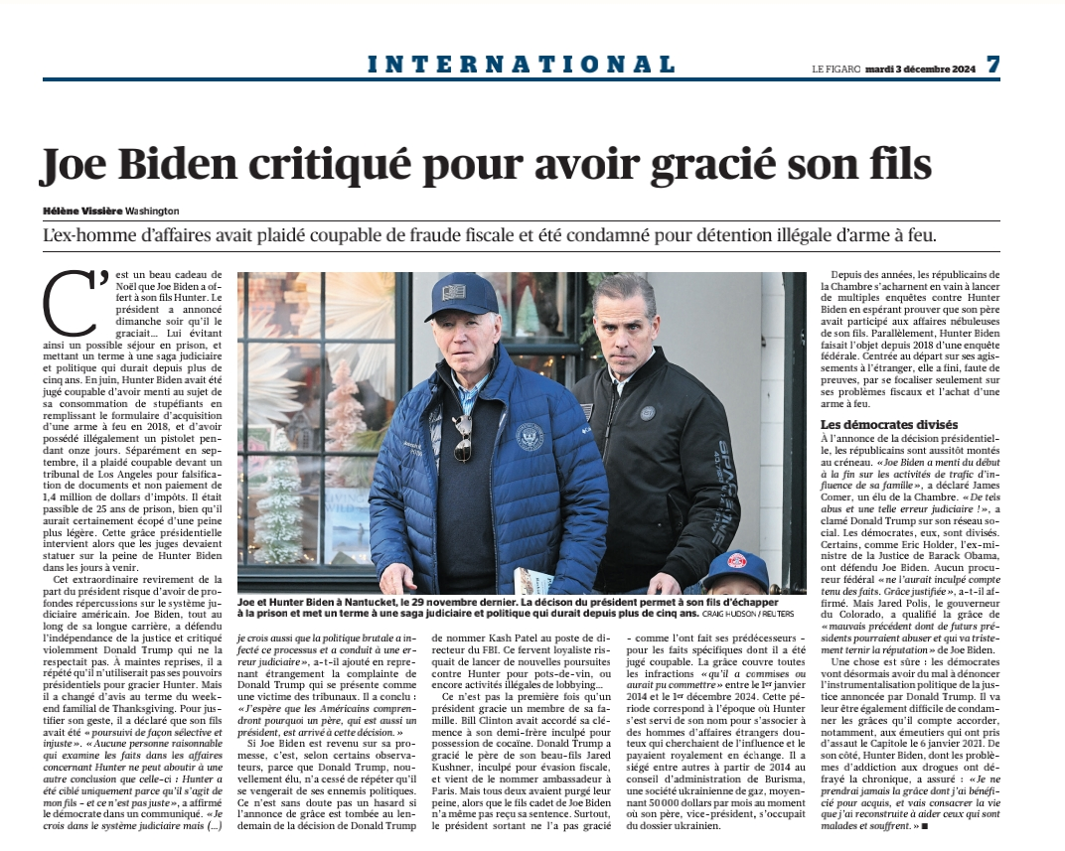

Ordinateur
<iframe width="250" src="https://www.youtube.com/embed/hPdBCwYGE-4?rel=0&cc_load_policy=0" title="YouTube : hPdBCwYGE-4" frameborder="0" allow="accelerometer; autoplay; clipboard-write; encrypted-media; gyroscope; picture-in-picture; web-share" referrerpolicy="strict-origin-when-cross-origin" allowfullscreen></iframe>
<iframe width="300" height="180" src="https://www.youtube.com/embed/Iqq0P1sC48U?rel=0&#t=4.0" frameborder="0" allow="accelerometer; autoplay; clipboard-write; encrypted-media; gyroscope; picture-in-picture; web-share" referrerpolicy="strict-origin-when-cross-origin" allowfullscreen></iframe>

Comments
https://youtu.be/hPdBCwYGE-4?si=b9qw_hAF08CGWywb


