La mode, les défilés, la fascination du luxe et du "Populaire"
<iframe width="250" src="https://www.youtube.com/embed/BSutwiomVtc?rel=0&cc_load_policy=0" title="YouTube : BSutwiomVtc" frameborder="0" allow="accelerometer; autoplay; clipboard-write; encrypted-media; gyroscope; picture-in-picture; web-share" referrerpolicy="strict-origin-when-cross-origin" allowfullscreen></iframe>
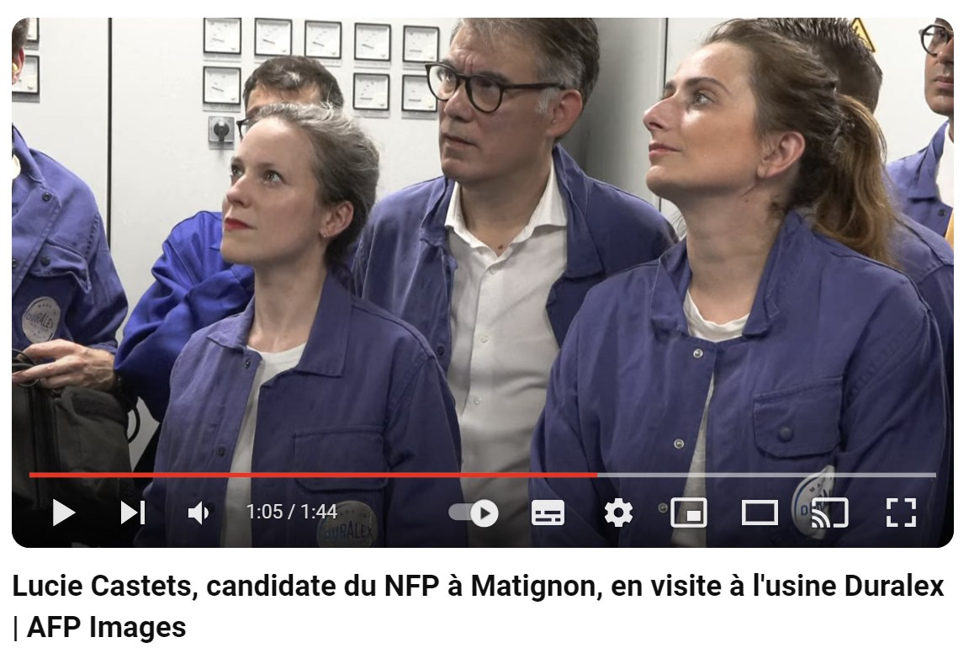

Comments


