La bonne vision du monde qui permet de vivre en société
<iframe width="180" src="https://www.youtube.com/embed/bSmtYShGE7U?rel=0&cc_load_policy=0" title="YouTube : bSmtYShGE7U" frameborder="0" allow="accelerometer; autoplay; clipboard-write; encrypted-media; gyroscope; picture-in-picture; web-share" referrerpolicy="strict-origin-when-cross-origin" allowfullscreen></iframe>
×× La censure zuckerberg-covid ++++
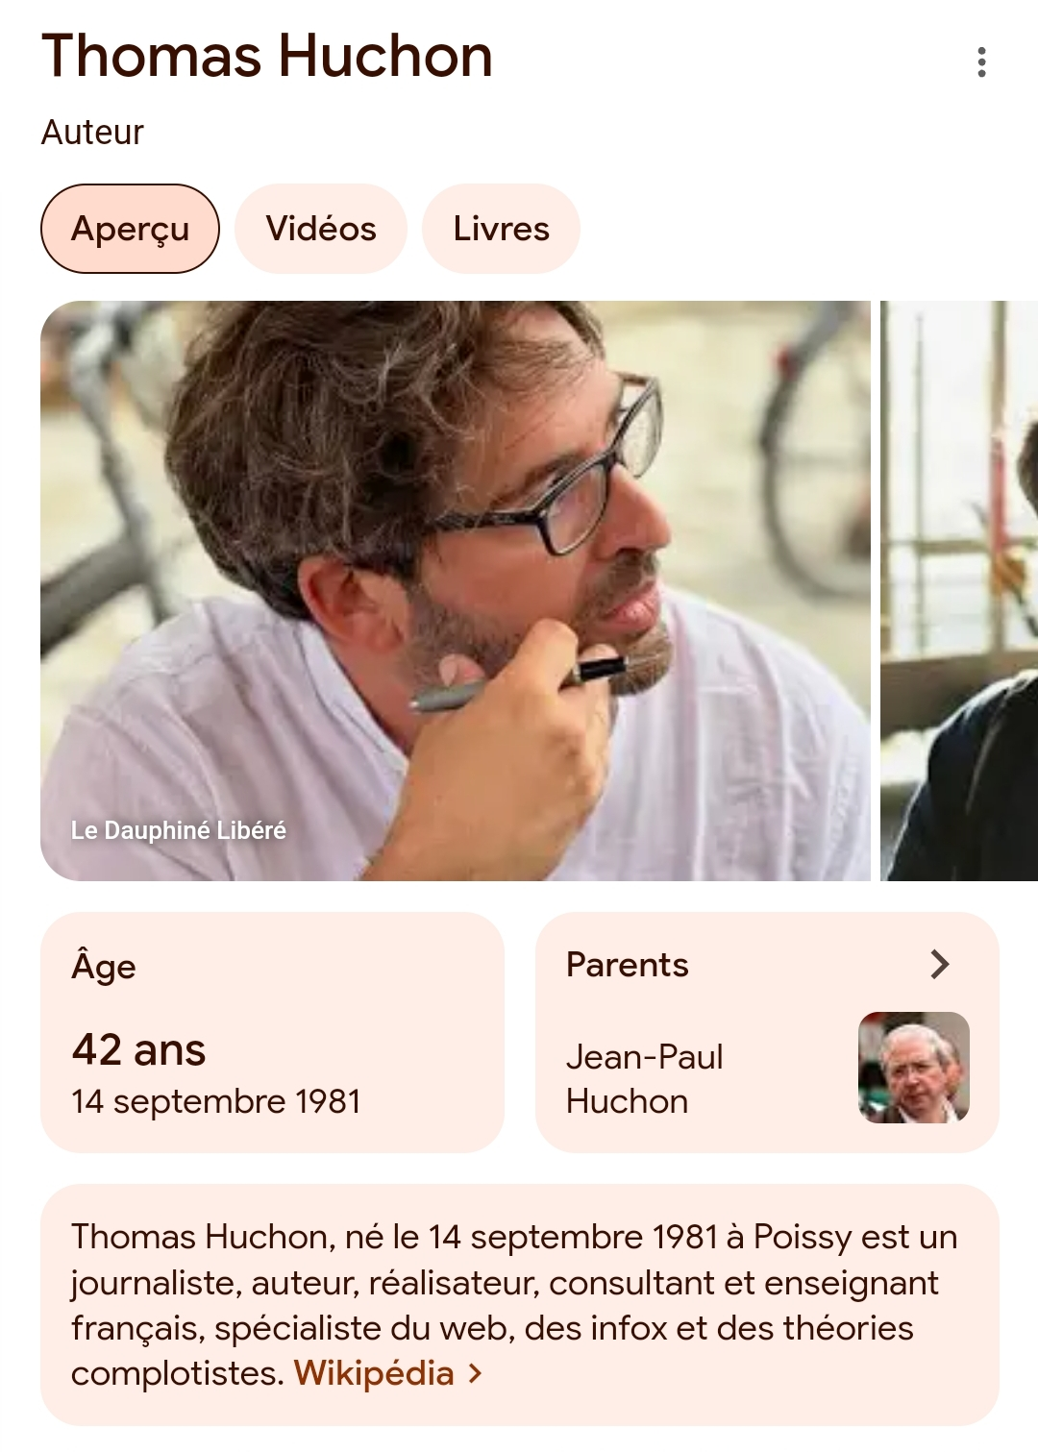

https://youtube.com/@lecrayonmedia?si=gqN_8-BsJgHwc6ZI

Comments


